

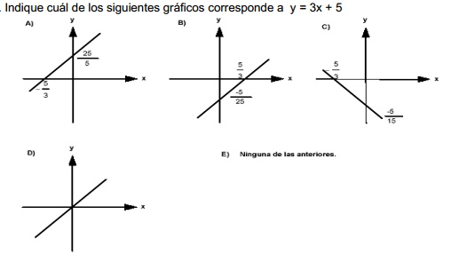

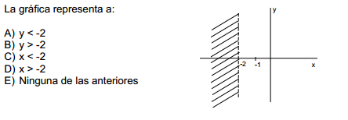

.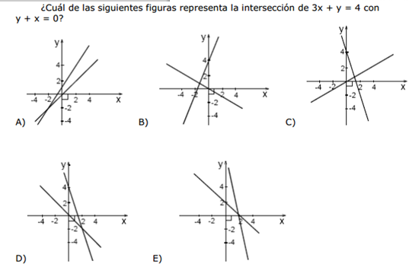

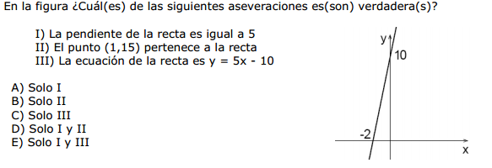

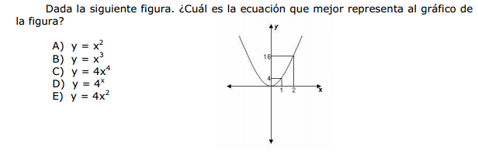

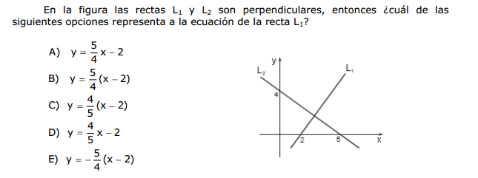

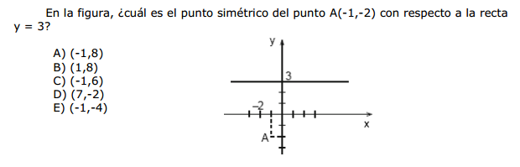

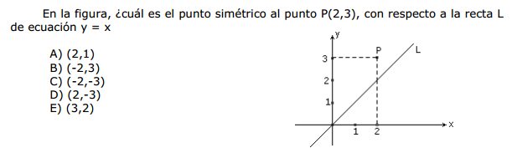

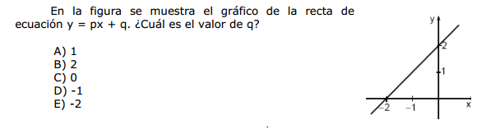

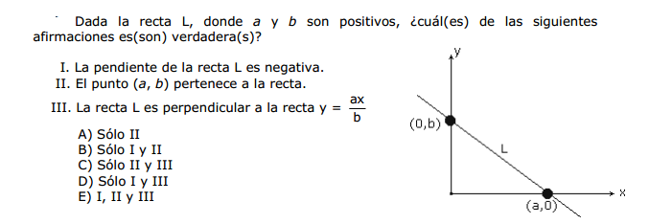

|  |  |  |  |  |  |  |  |  |  |
| --- | --- | --- | --- | --- | --- | --- | --- | --- | --- |
| 1-. A | 2-.C | 3-.D | 4-.D | 5-.E | 6-. B | 7-.A | 8-.E | 9-. B | 10-.D |